Pack 998 Registration Guide
Below is a guide to registering for Scouts and with our Pack. This guide is based on the best information we have available as of 8/2026. There were significant changes over the past year to this process so if you run into any issues please reach out to us at pack998leesburg@gmail.com. We will work with you to get them sorted out and if you find any part of this guide to be inaccurate please let us know so we can update it and our Join Us page on pack998.com.
Finally, if you need financial assistance with either Registration or the Pack Dues, please let us know as those are available.
All Scouts – Pack 998 Registration
Whether you are a new or returning Scout you need to complete the registration process for Pack 998. To do this:
- Complete the Pack Registration Form which provides us basic information about each Scout and needs to be updated annually. The link is: https://forms.gle/jmEZt31VAyjfaQBCA.
- Pay Pack Dues of $85 via Venmo (@PackNineNineEight-Treasurer) or check payable to Pack 998. These dues cover Pack expenses including awards, the Pinewood Derby, Class B shirts and the cost to register our leaders.
- Complete our Yearly Activities which are the Personal Safety adventure and the Health Form that you will need to bring to the Fall or Spring Camp Out.
New Scouts
Welcome to Scouting! Your process is pretty straightforward, hopefully =)
- Go to our registration site: https://my.scouting.org/online-registration/b6c6980e-e900-42c2-bbe4-39f348b8eb06/applicant-type. You can also find us by searching for Packs in our zip code (20175) on the Find Scouting Near You site: https://beascout.scouting.org/.
- Start the “Youth” registration and once completed you should be given a Scouting ID. Email that ID to Andrew @ pack998leesburg@gmail.com.
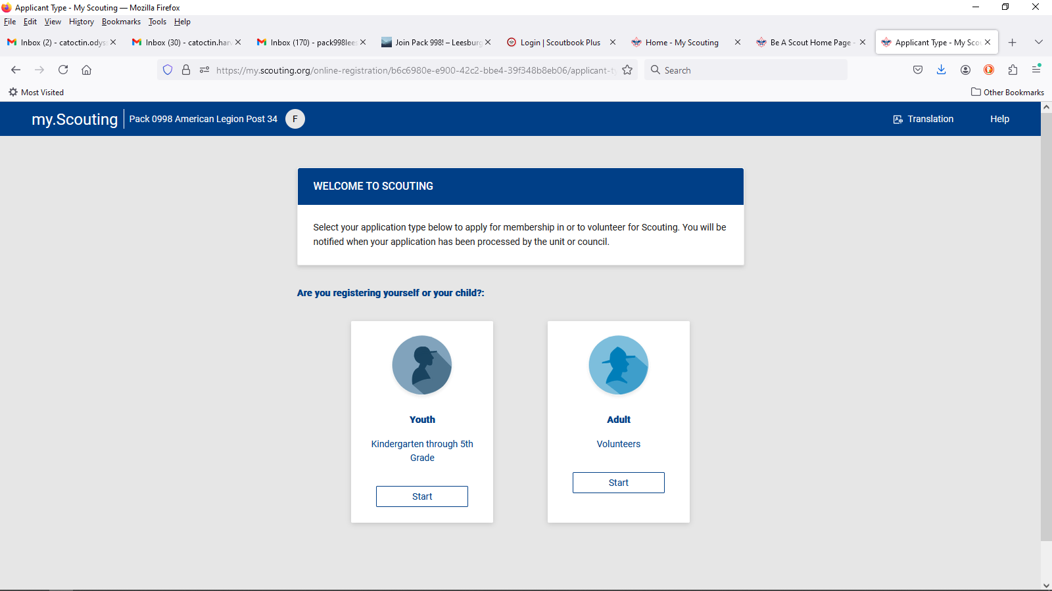
Make sure this says Pack 998.

- Registrations Fees are: New Scout Registration - $25, National Fee - $85, NCAC Participation Fee - $80 and Scouting Life - $15 (Optional).

Scouts Transferring to Pack 998
Your process is the same as returning Scouts; the added step is transferring your Scout to Pack 998. This process has not been functioning well so may take a few iterations. For now, please send the following to Andrew @ pack998leesburg@gmail.com:
- Scout’s Name, DoB and Membership ID (found at https://www.scouting.org/)
Returning Scouts to Pack 998
As I mentioned, Scouting USA moved from a Recharter system which closed at year end to an annual registration process. Below is a brief summary of that process:
- Scouts Who Initially Registered Prior to 06/2023 – Any Scout who has been a member prior to 06/2023 is part of the old recharter system. Therefore your annual membership renewal will be in December of each year.
- Scouts Who Initially Registered after 06/2023 – If you signed up for Scouting after 06/2023 you are part of the new annual renewal process. Your renewal date is the anniversary of your initial registration.
- Annual Renewal Process
  - Look for an email from Scouting USA indicating you are due to renew your membership. You should receive this notification 60 days prior to your renewal date. Note: If anyone has received this email and can forward it to me so I can see what it looks like, I’d appreciate it.
  - Login to https://www.scouting.org/ and after logging in, select the My Applications tab. You will find the membership renewal there, and it should look like this:
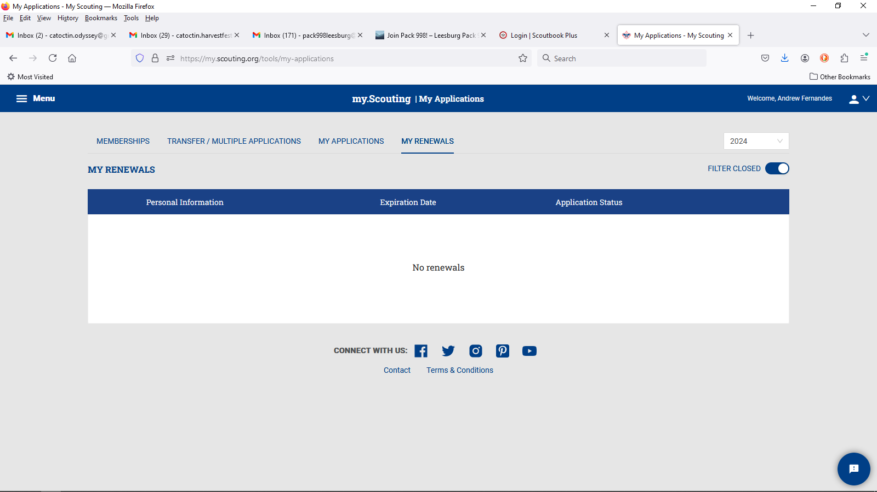

  - Pay the Registration Fees:
    - National - $85, Scouting Life (Optional) - $15 & NCAC Participation Fee - $80

Pack Recharter
Under this new process the Pack’s Recharter is simplified and all it requires is that we have the necessary leadership positions filled with those leaders having completed their Youth Safety Training (Previously YPT) and that we pay the appropriate fees for them. This process will occur in November/December.
Note: This process is changing and Scouts and Units will be moving to a common recharter date in February-2028.

